Assignment 2

Name : Sanket Rajaram Mote

PRN : 2019BTECS00113

Batch : T5

Course : Software Engineering Tools Lab

Anaconda

1. Original author

**Ans.** Peter Wang and Travis Oliphant

1. Developers

Ans. Anaconda, Inc. (previously Continuum Analytics)

1. Initial release

**Ans.** 0.8.0/17 July 2012

1. Stable release

**Ans.** 2021.11 / 17 November 2021

1. Repository (with cloud support)

**Ans.** Anaconda Repository is an enterprise server on your network or your private cloud where open source and proprietary packages may be stored, retrieved, and shared.

1. Written in (Languages)

**Ans.** Python

1. Operating System support

**Ans.** Windows, Linux, Mac OS

1. Platform, portability

**Ans**. Platform: Anaconda Navigator

1. Available in (Total languages)

**Ans**. Python & R

1. List of languages supported

**Ans**. Python & R

1. Type (Programming tool, integrated development environment etc.)

**Ans**. Anaconda is a distribution of the Python and R programming languages for scientific computing (data science, machine learning applications, large-scale data processing, etc.), that aims to simplify package management and deployment.

1. Website

**Ans**. <https://www.anaconda.com/>

1. Features

**Ans.**

• It has more than 1500 Python/R data science packages.

• Anaconda simplifies package management and deployment.

• It has tools to easily collect data from sources using machine learning and AI.

• It is free and open-source.

1. Size (in MB, GB etc.)

**Ans**. The current download size sits at around 600MB and will take up over 2GB of disk space once installed

1. Type of software (Open source/License):

**Ans**. Free and Open-Software Software.

1. If License- Provide details.

**Ans**. Anaconda Individual Edition 2021.11.

1. Latest version

**Ans**.

1. Cloud support (Yes/No)

**Ans**. Yes

**I. Implement linear regression problem using Google colab (Perform pre-processing, training, and testing)**

Dataset 6- <https://archive.ics.uci.edu/ml/datasets/Hungarian+Chickenpox+Cases>

**Implementation:**

**1.Pre-processing:**

a. Getting the dataset, reading it, and importing required libraries.

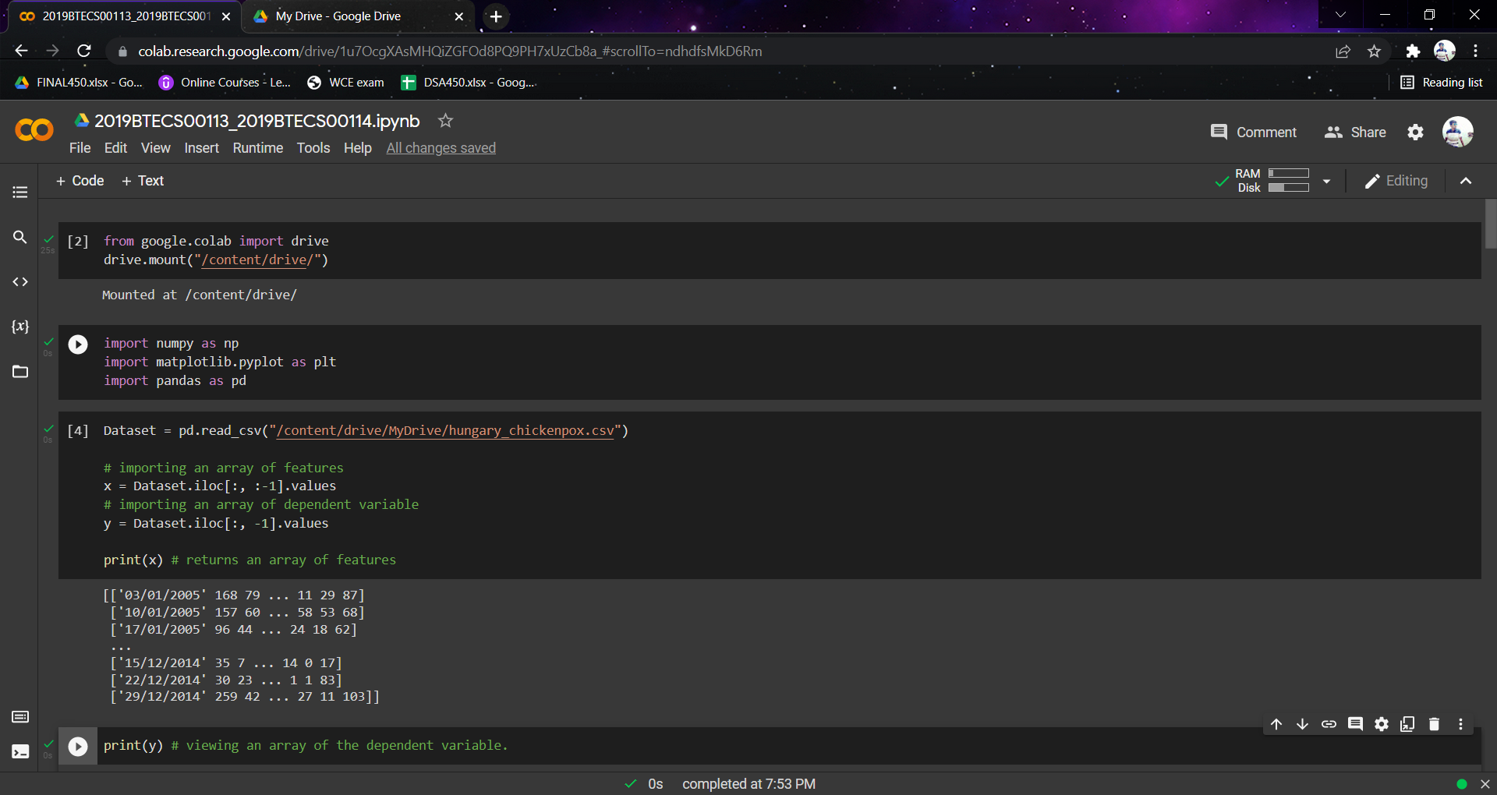

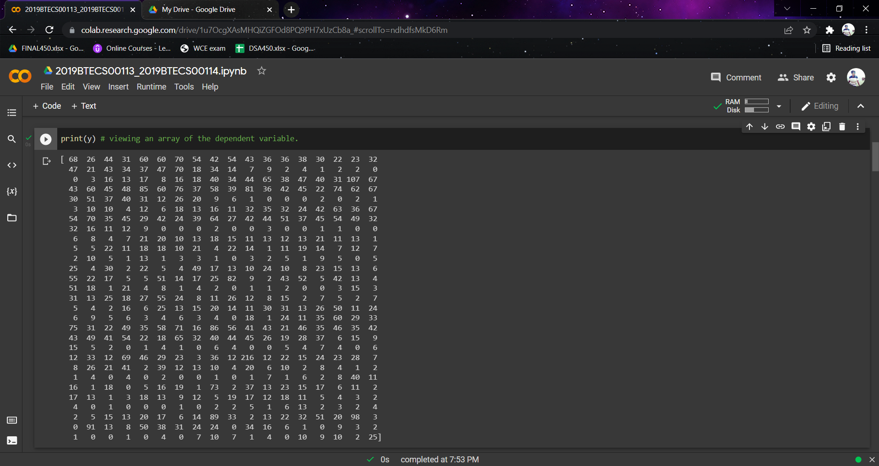

b. Handling missing data.

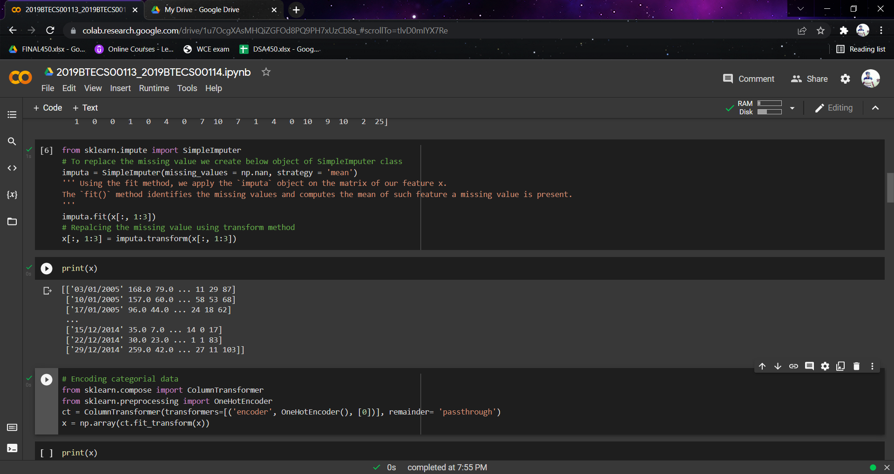

c. Encoding Categorial Data

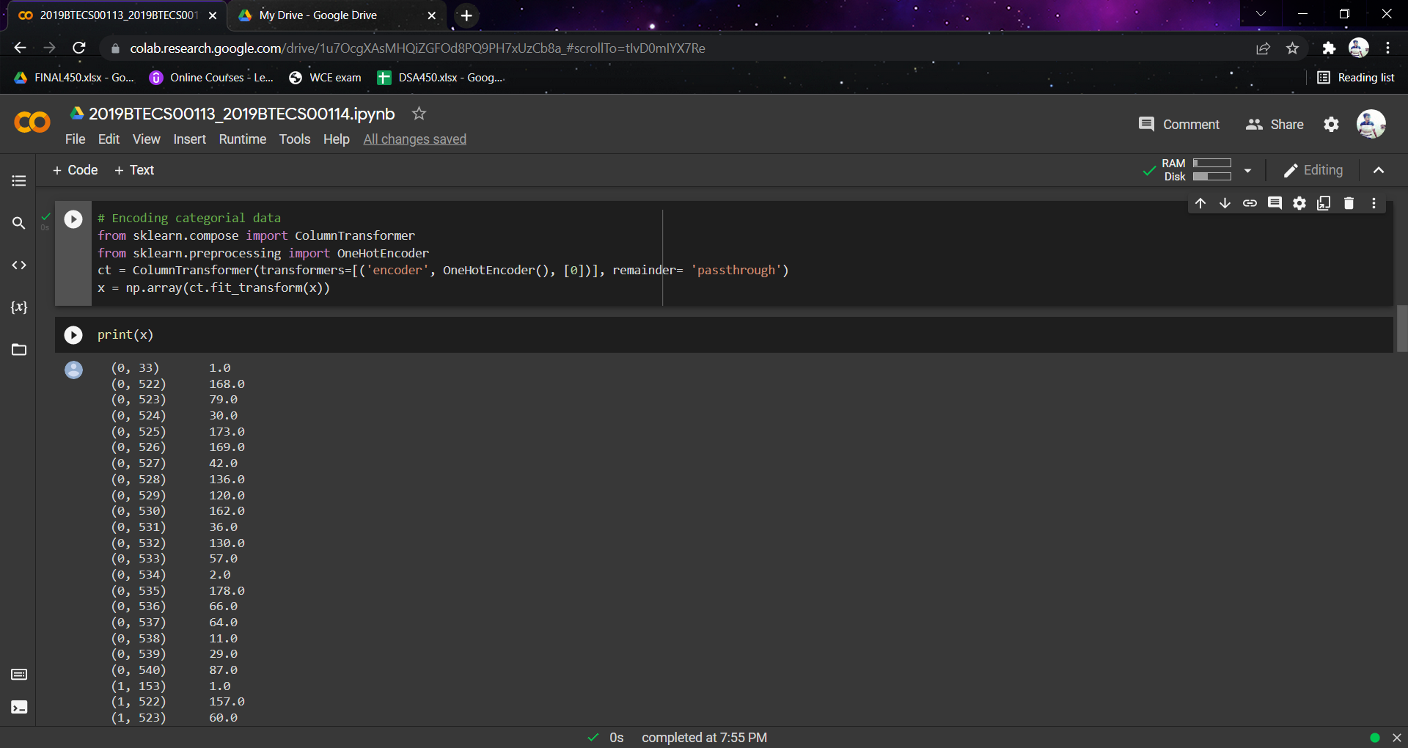

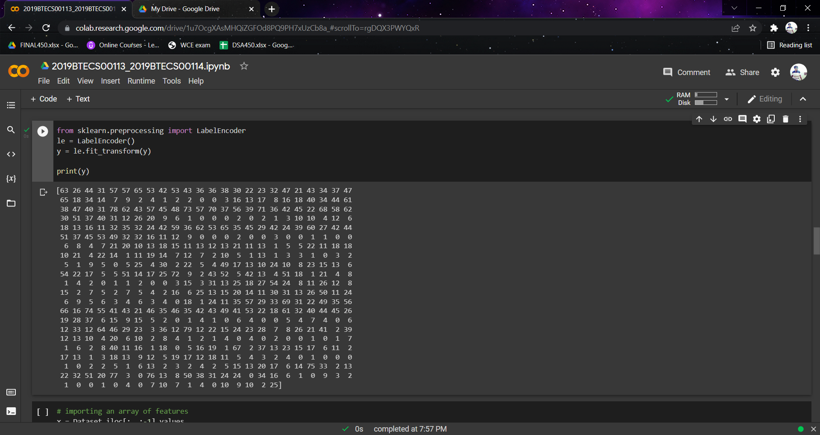

**2. Training and Testing**

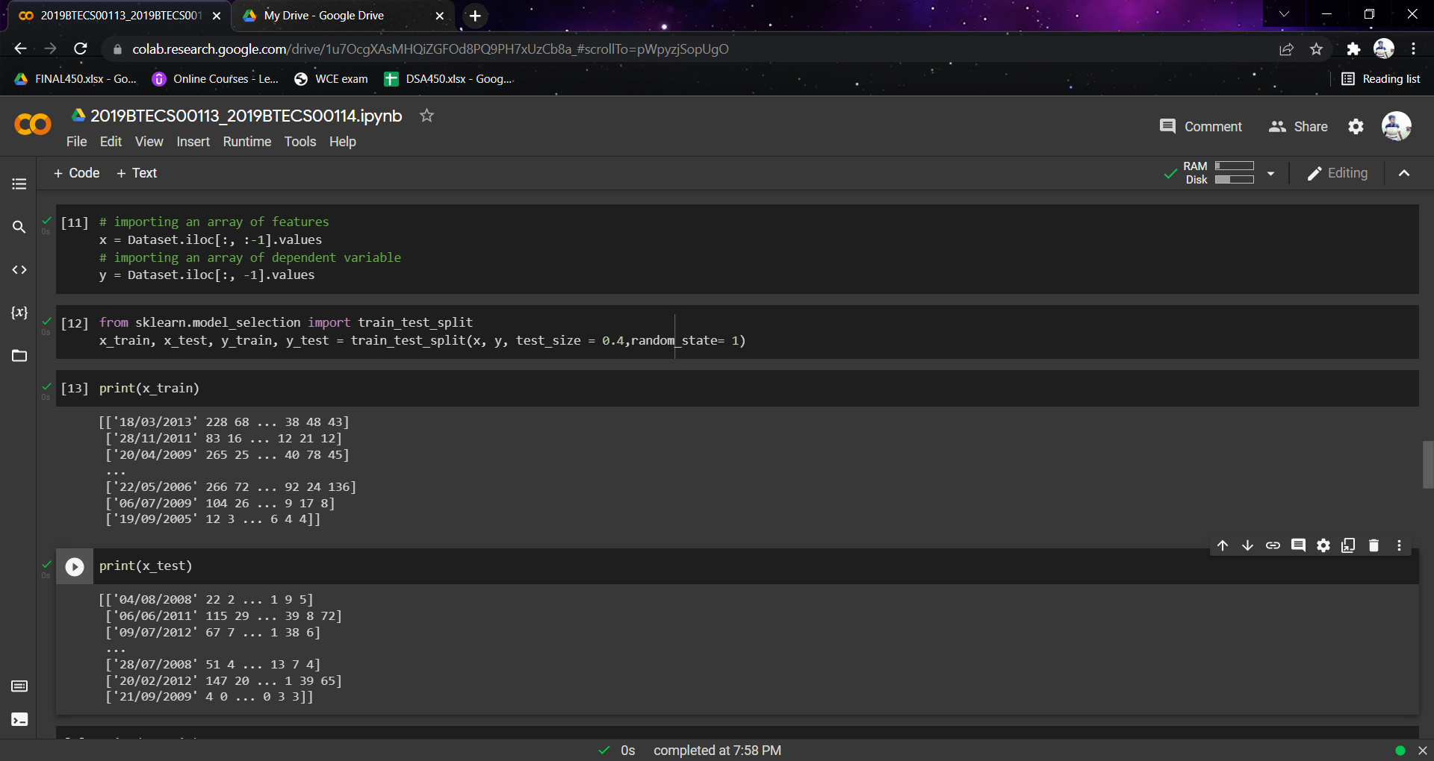

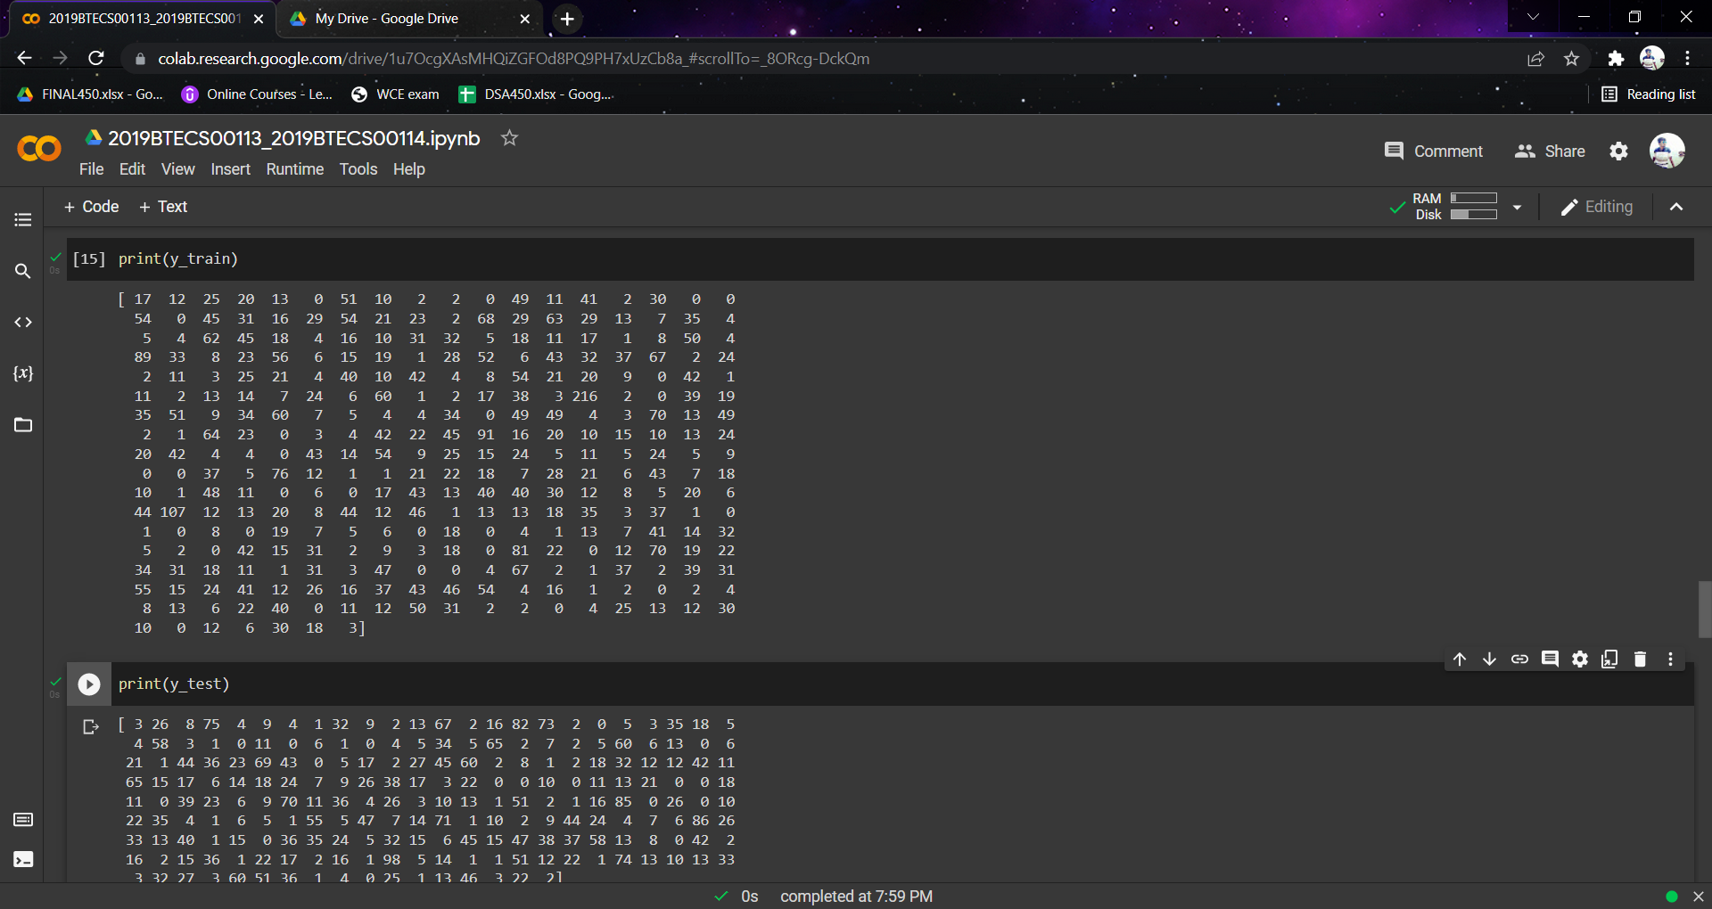

**3. Feature Scaling**



